BUSINESS ANALYTICS WITH EXCEL

DESIGNING An E-COMMERCE SALES DASHBOARD IN EXCEL


Certified Business Analysis Professional (CBAP®)
Certification Project

Submitted by AMRUTHAM VENU

DESCRIPTION:
Use Excel to analyse the sales based on various product categories.
The dataset in file E-Commerce Dashboard dataset.xlsx contains sales data for different product categories. The following are the features in the dataset:
Order ID | Unique Order ID of a product
Order Date | Order Placement Date
Ship Date | Shipment Date of the placed order
Aging
Ship Mode | Shipment mode of placed order
Product Category | Product Category
Product | Name of the Product
Sales | Sales Amount
Quantity | The amount or number of a material
Discount | A deduction from the usual cost of something
Profit | A financial advantage or benefit
Shipping Cost | The amount required to ship the placed order
Order Priority | Precedence of placed order
Customer ID | Unique Customer ID
Customer Name | Name of the Customer
City | Unique City Name
State | Unique State Name
Country | Unique Country Name
Region | Especially the part of a country
Months | The month of placing the order

The following project tasks are required to be performed in Excel:
- Prepare a table of Sales and Profit month-wise in a working sheet.
- Prepare the sales table region-wise in the working sheet.
- Create User Control Combo box for Product Category.
- Create a Column Chart of the month-wise table and region-wise table.
- Link the table with a combo box.
- Create a dashboard.
Tools required: Microsoft Excel, Data Analysis Add-in

Expected Deliverables: Design a sales dashboard that analyses the sales based on various product categories. The company wants to add user control for product category so that users can select a category and can see the trend month-wise and product-wise accordingly.

Task 1: Prepare a table of Sales and Profit month-wise in a working sheet.

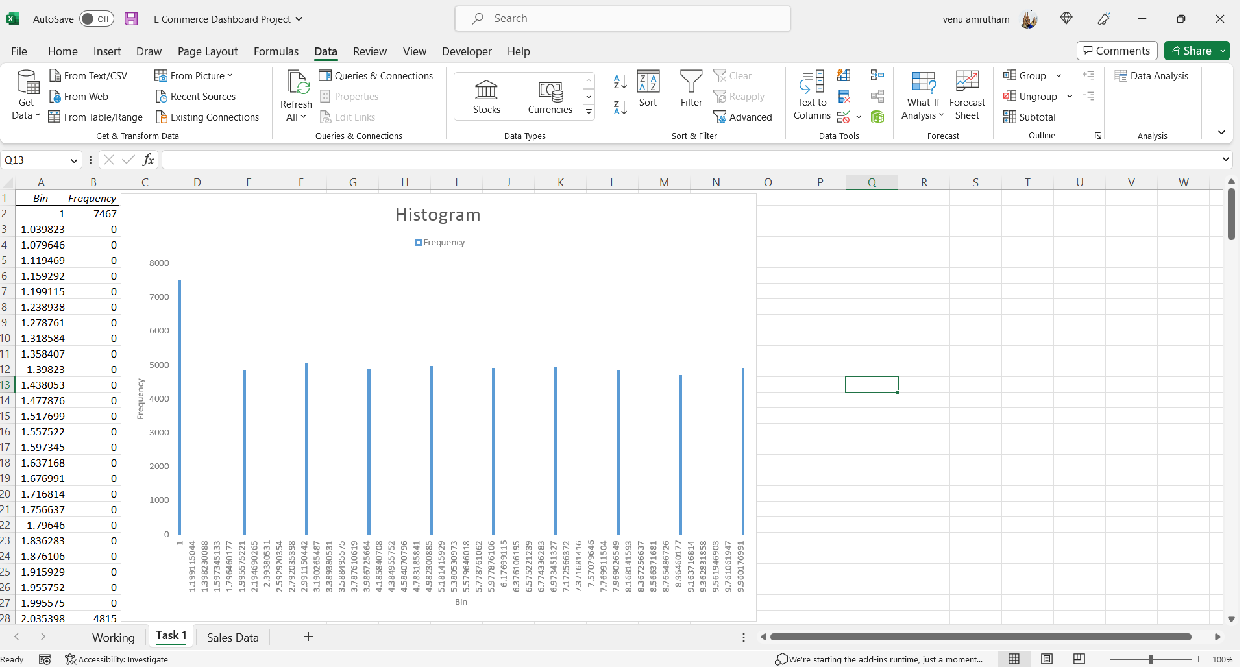

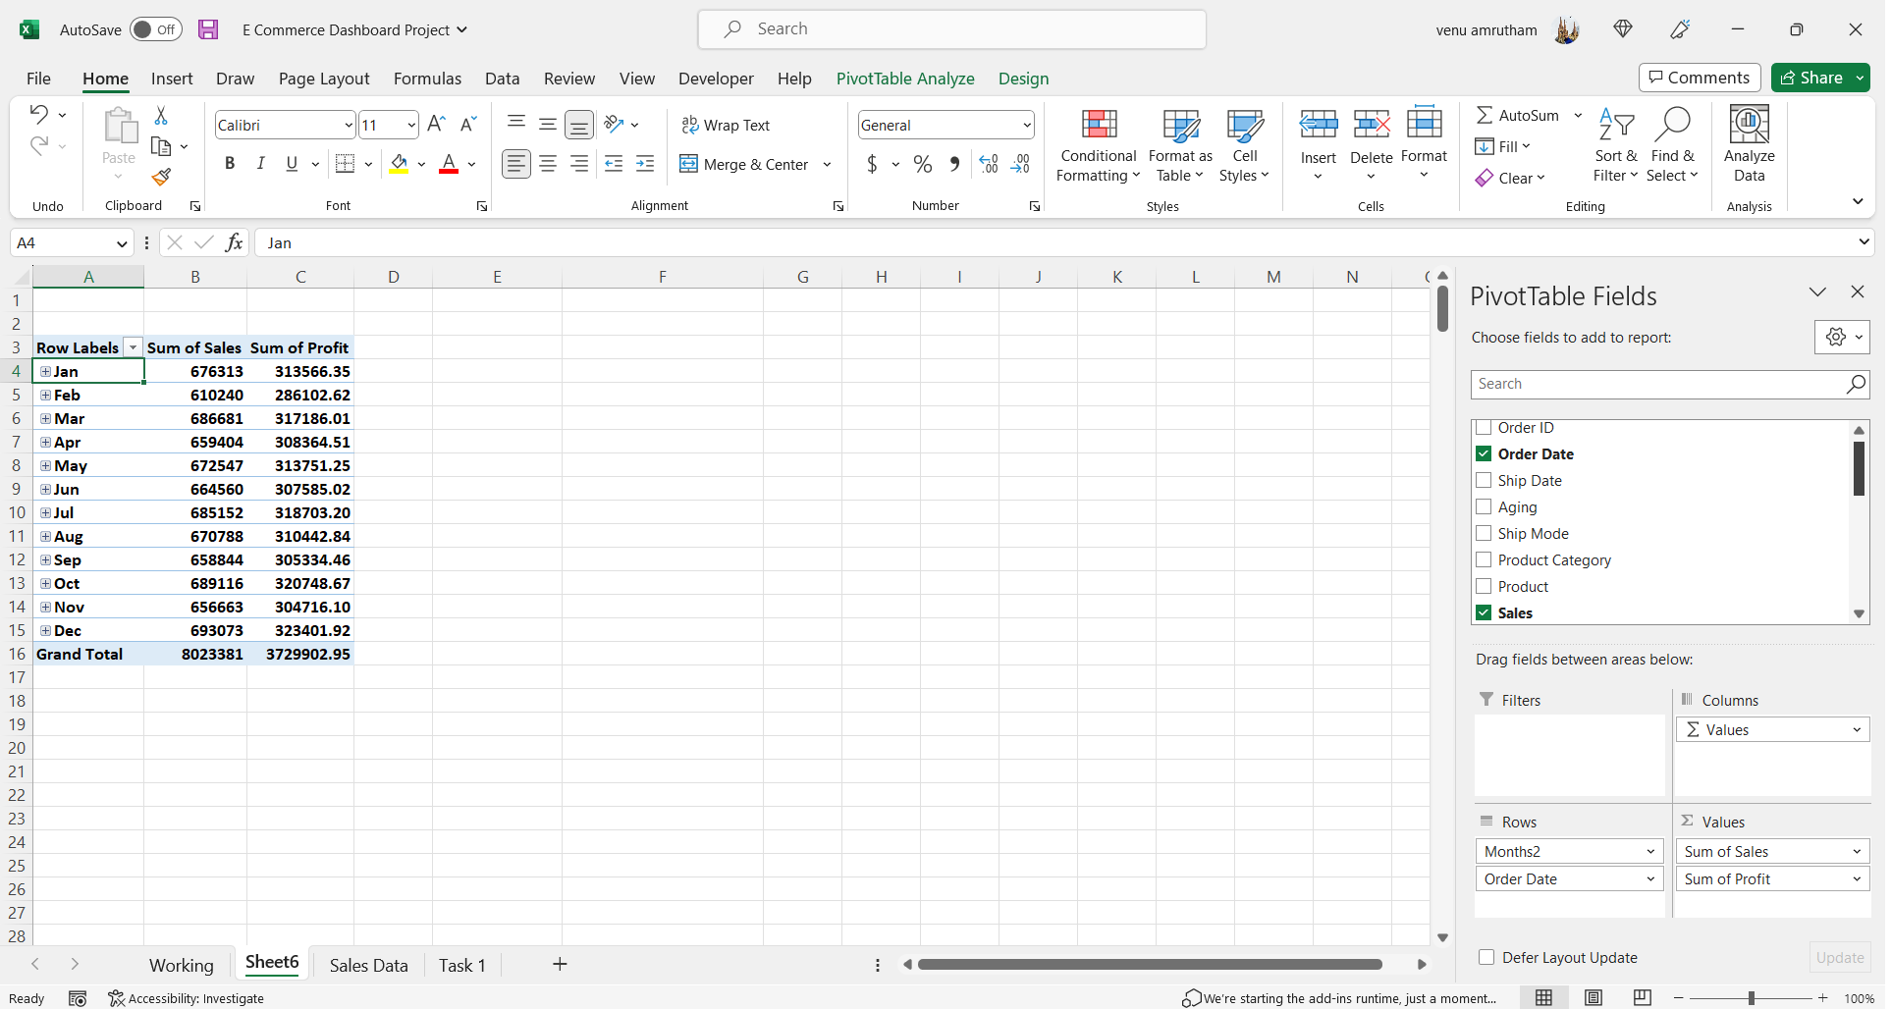

Task 2: Prepare the sales table region-wise in the working sheet.
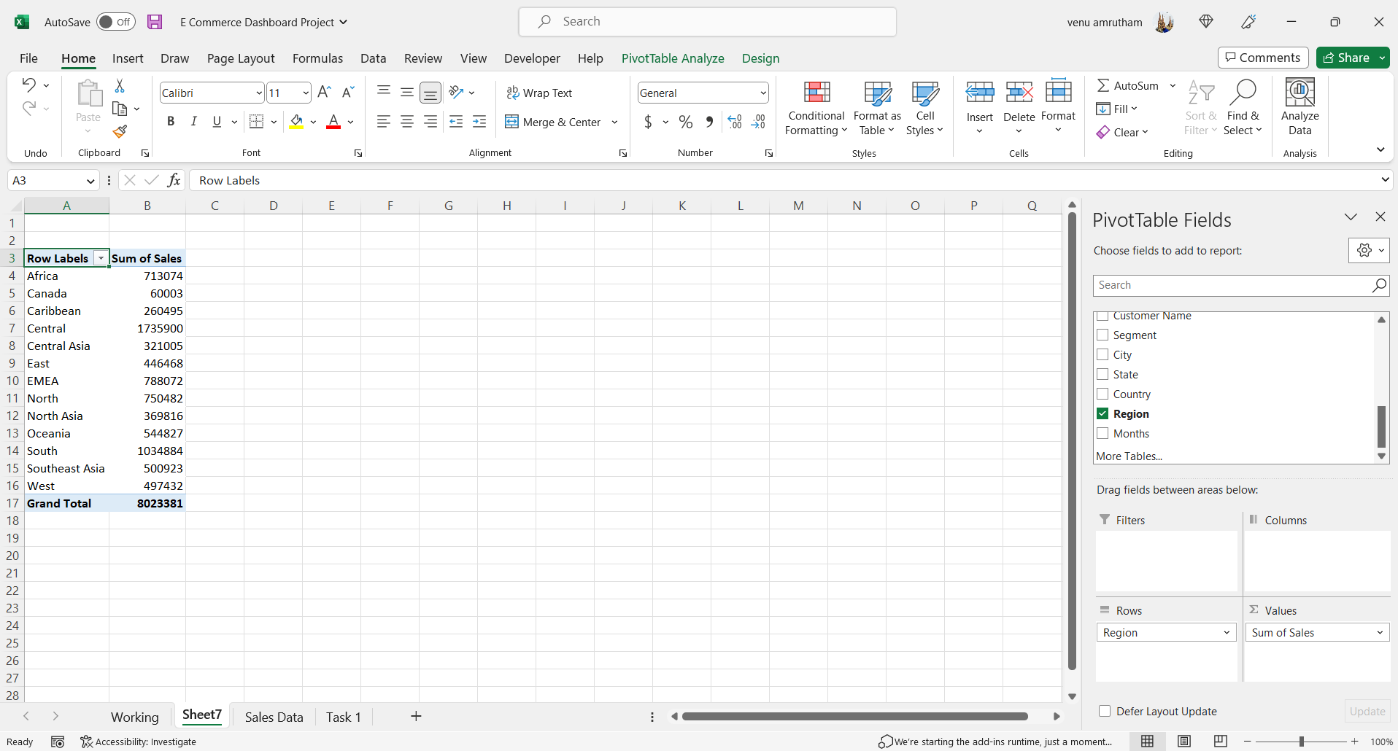

Task 3: Create User Control Combo box for Product Category.
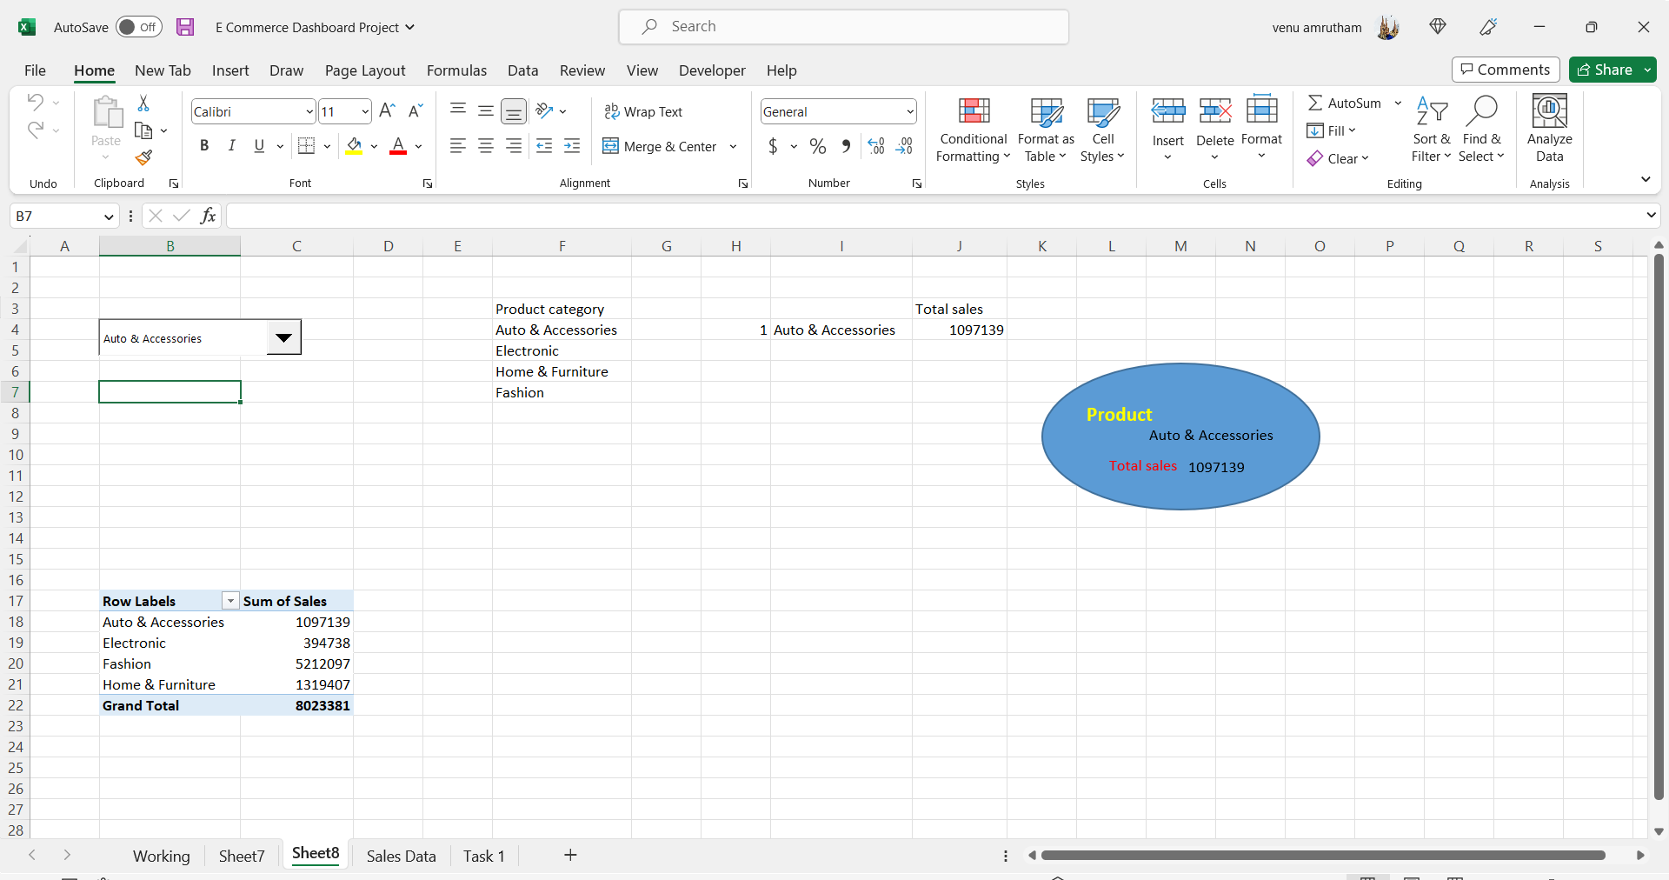

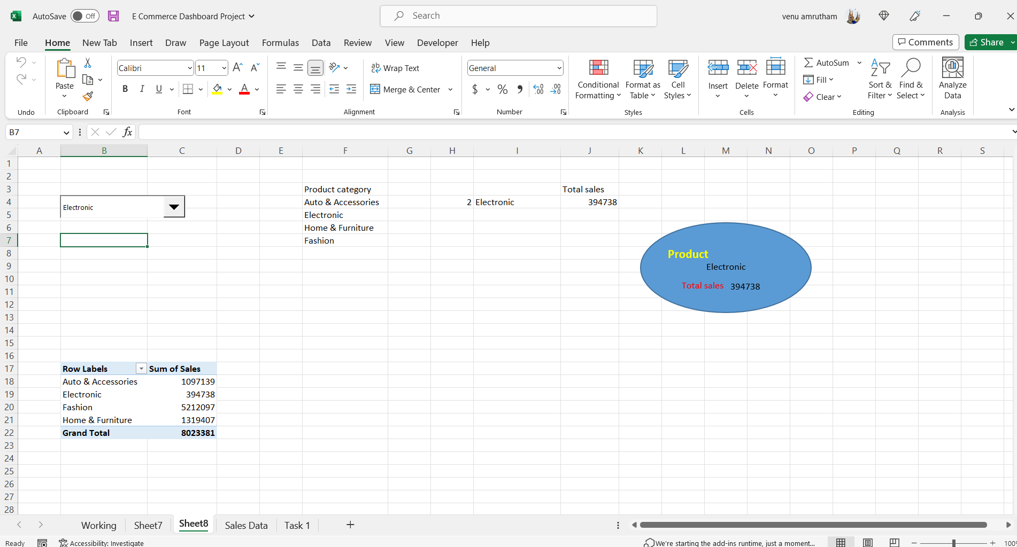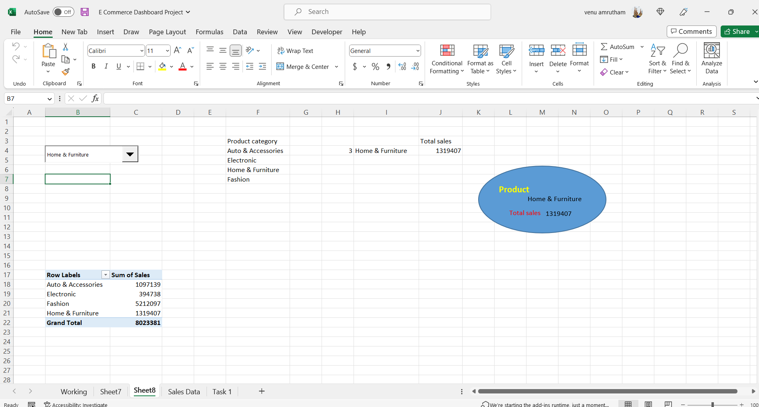

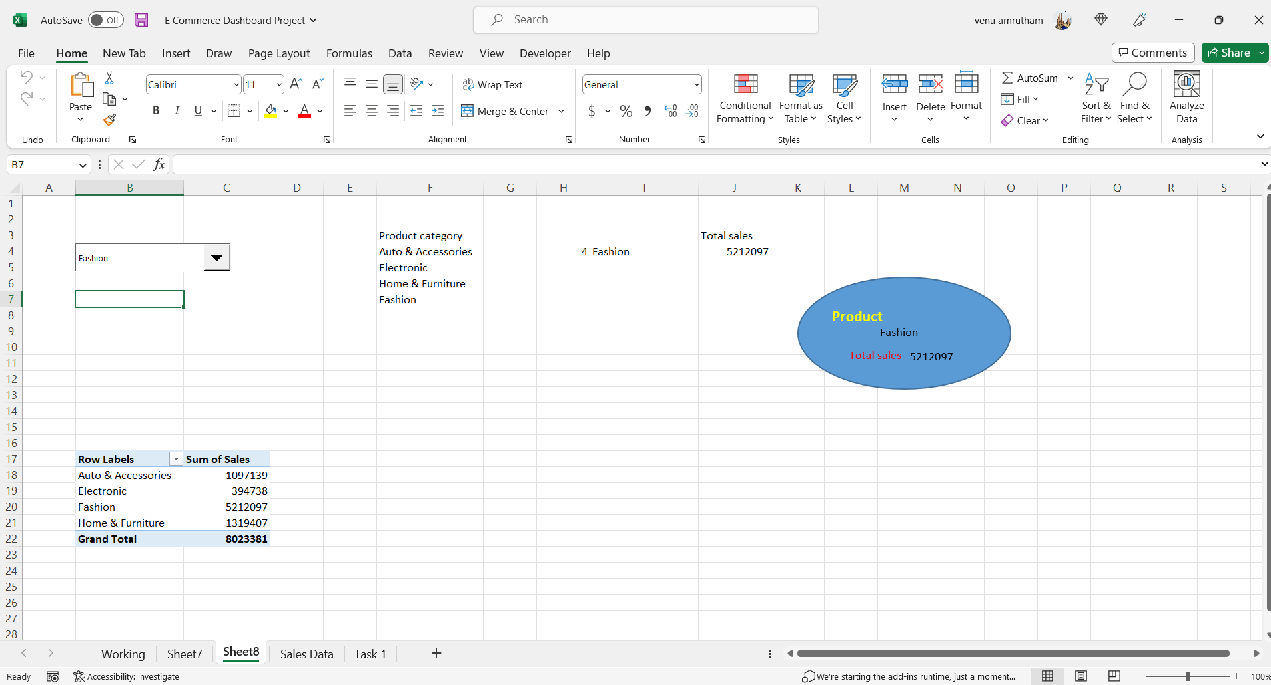

Task 4: Create a Column Chart of the month-wise table and region-wise table.

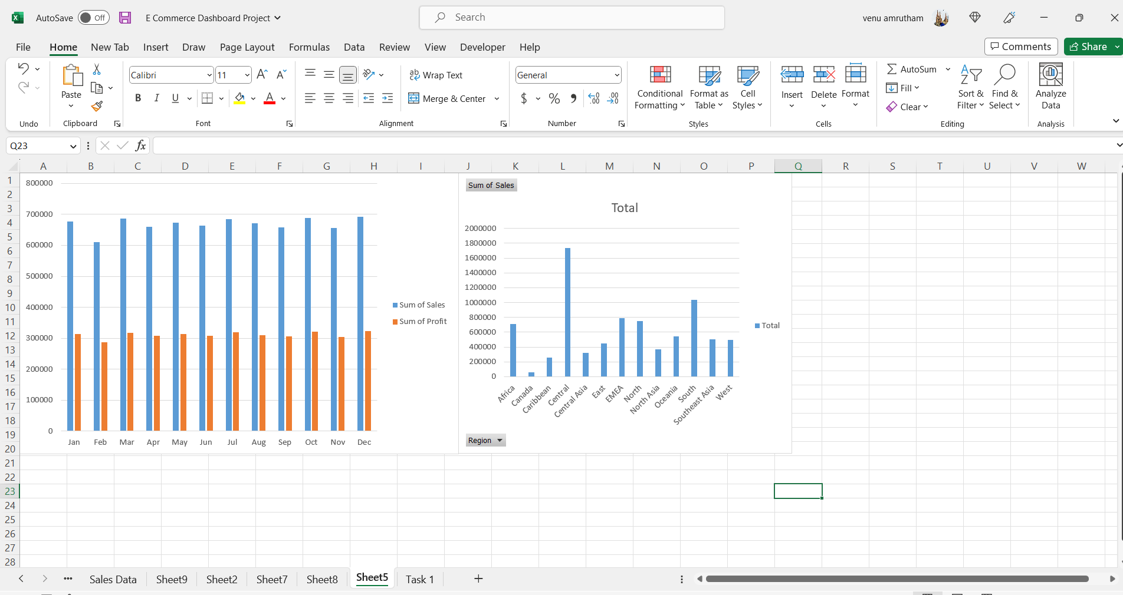

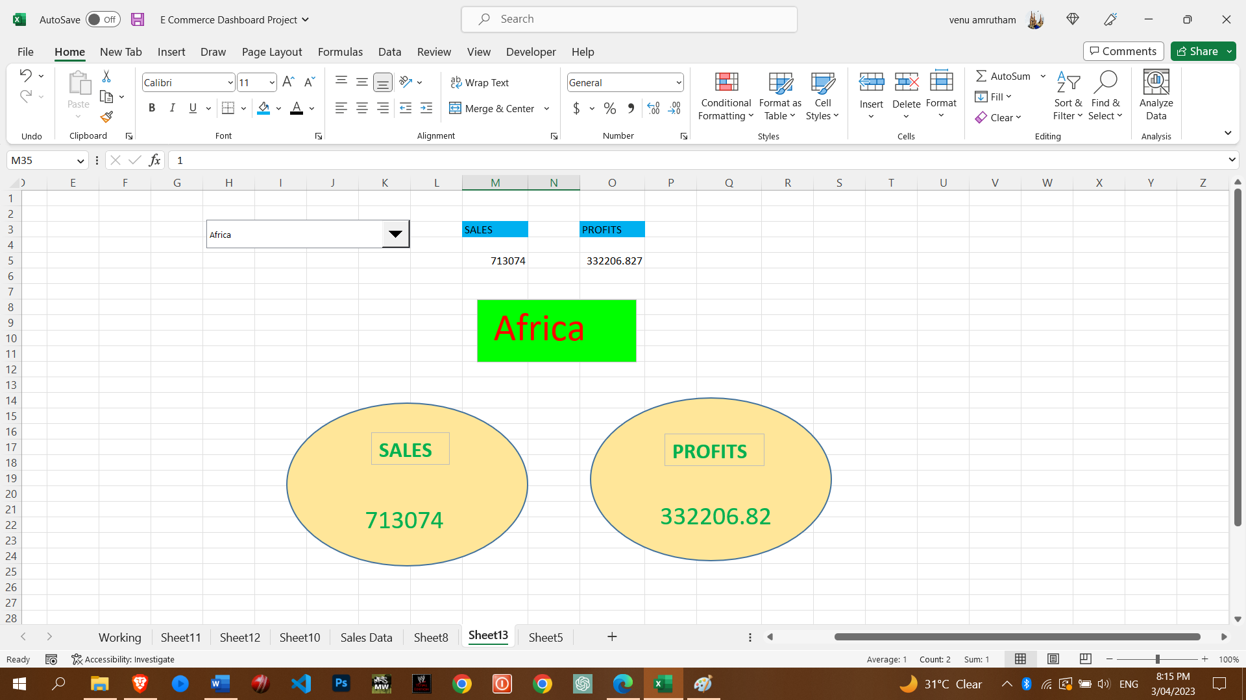
Task 5: Link the table with a combo box.

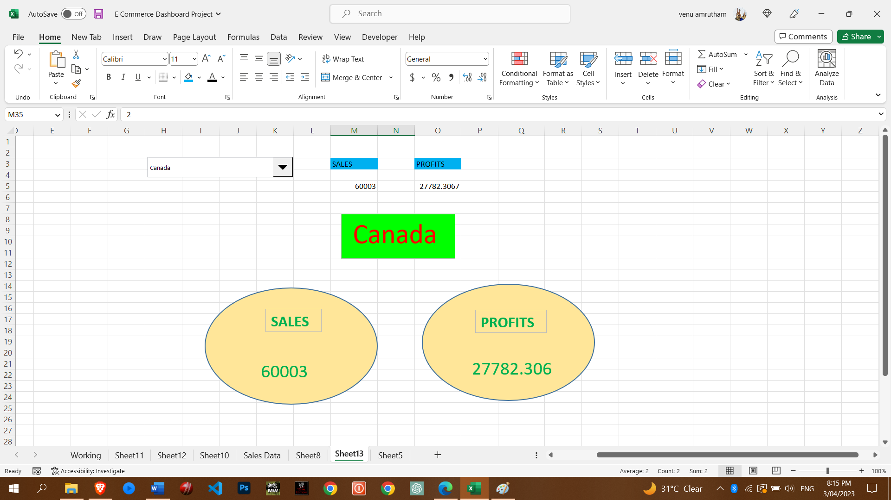

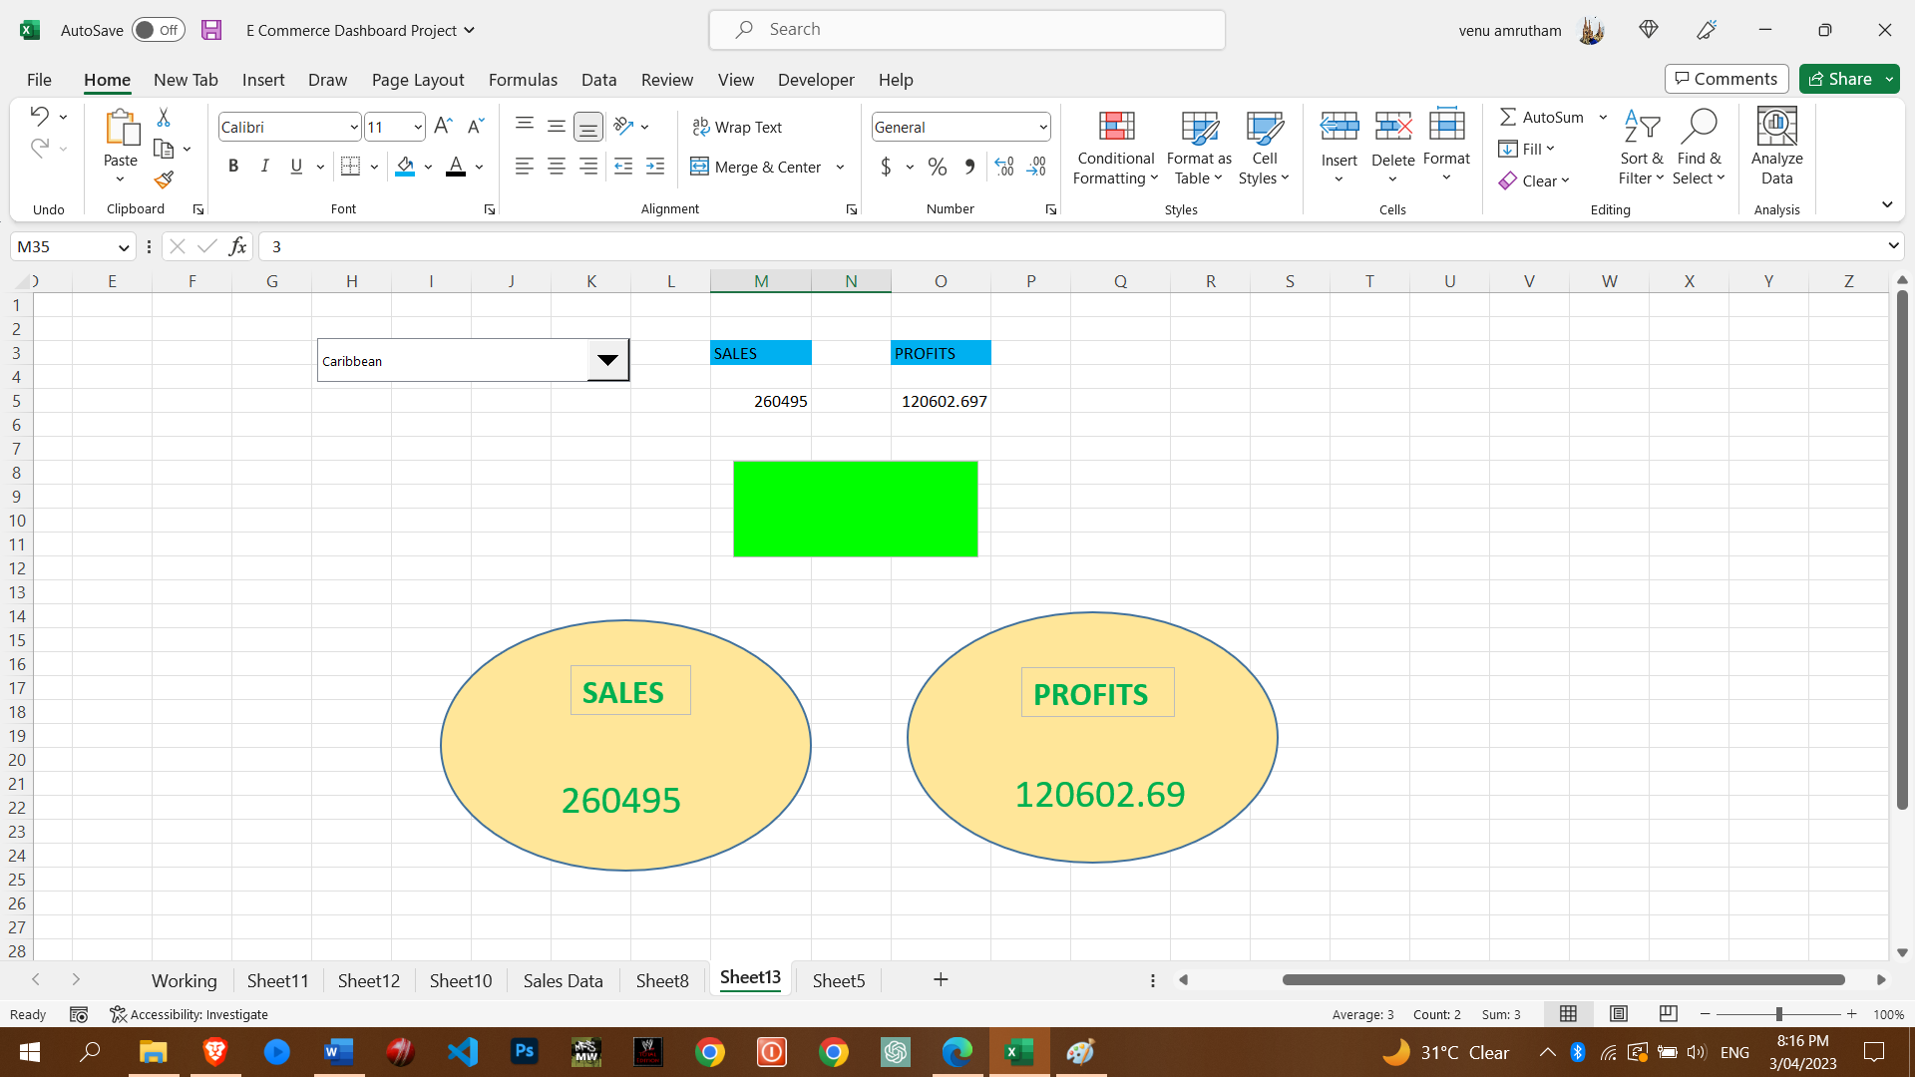

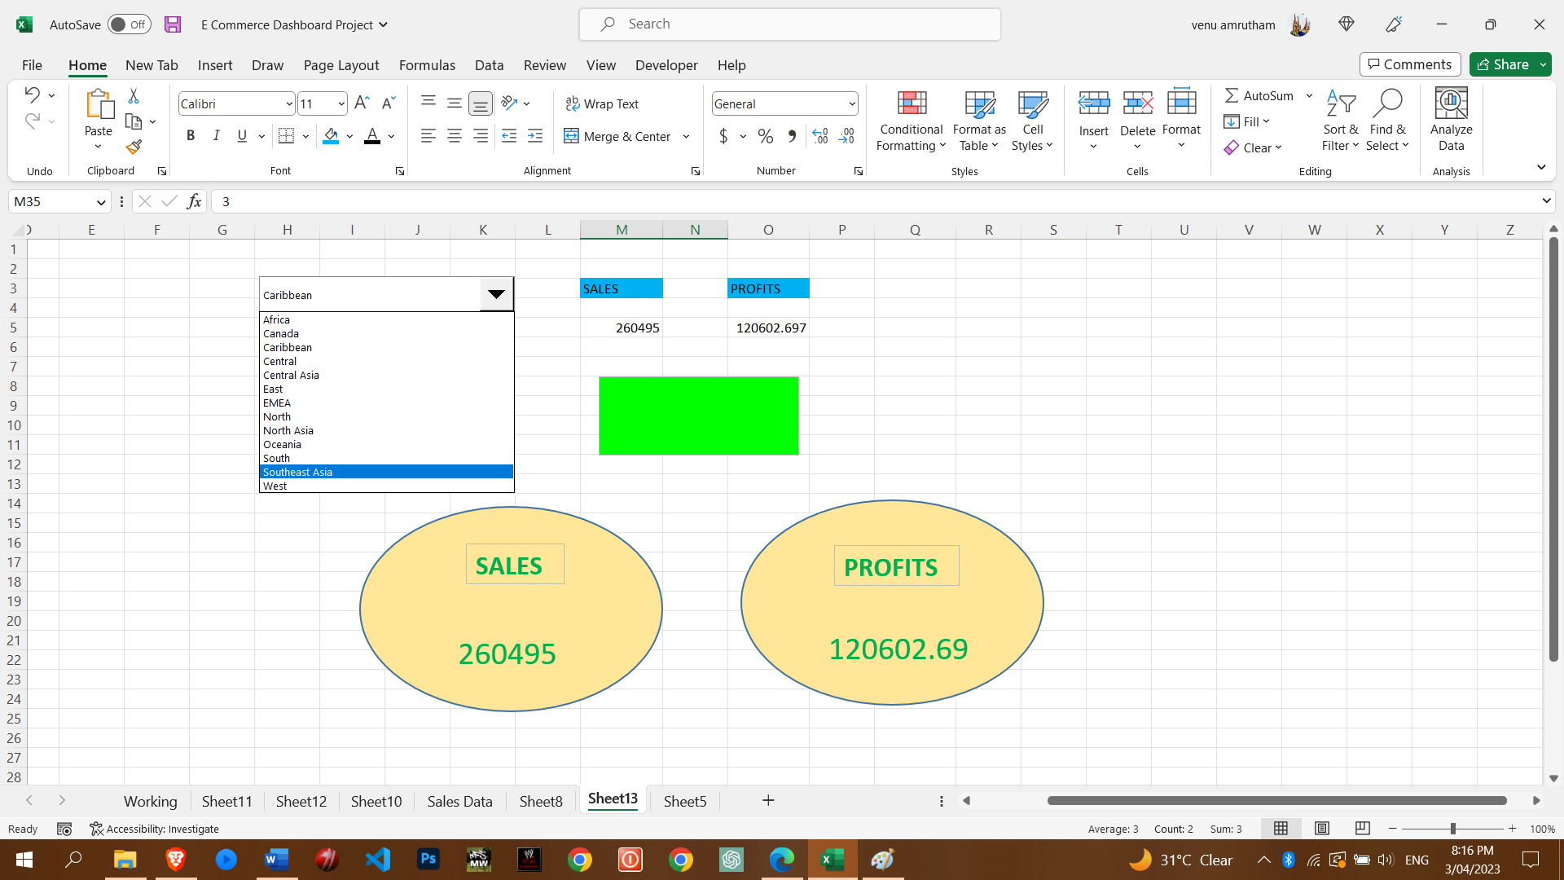

Task 6: Create a dashboard.

